Submitting Work in OneNote
**I will submit feedback to students in pink**

- Log into ClassLink https://launchpad.classlink.com/fcs
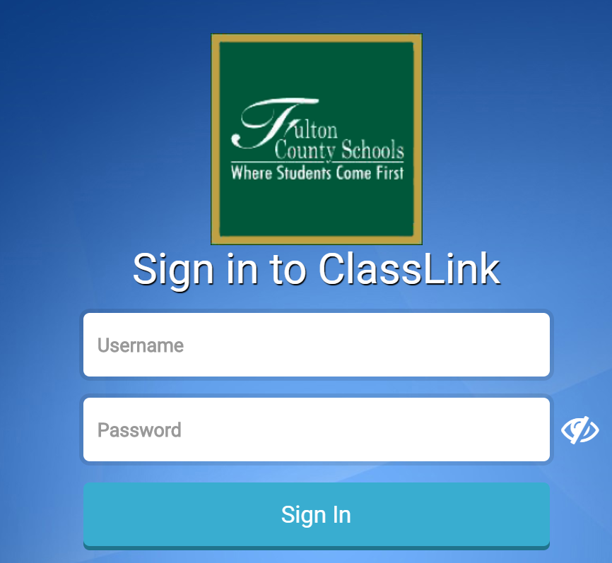

- Click on Office365.
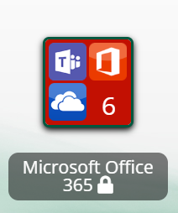
You may be asked to type in an email address by Microsoft. If so,
- Type in student’s email address.
- Student ID number with @fcstu.org
- Type in student’s password.
- Full birthdate with no dashes or spaces (000000)

- Click on OneNote.
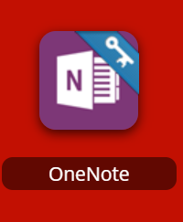

- Click on student’s name (should be on the right hand side).

- Click on the week tab (for example: Week of March 16).

- Click on the day of the week you are submitting work for (for example: Monday March 16th).

- Type in the assignment that was completed. Here you can add pictures of your work or type it in.
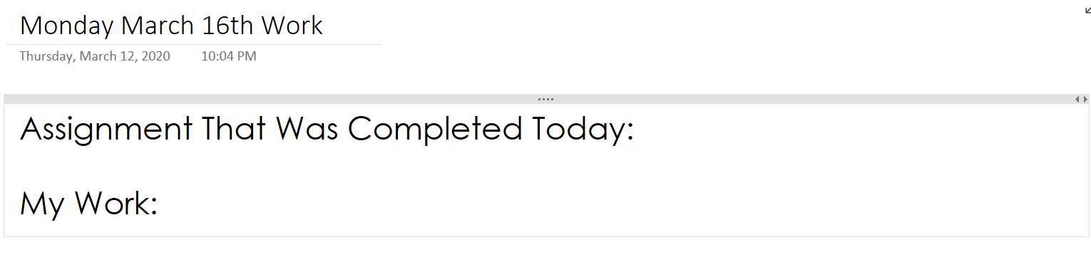
To insert pictures, make sure the picture is saved to your device and are on the page you want to upload to.
Click on Insert and then File Attachment.
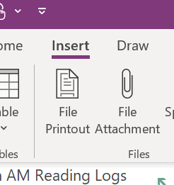

Then select the picture/document you want to attach.

Make sure you see SAVED at the top before exiting.

Submitting Work in OneNote
**I will submit feedback to students in pink**

- Log into ClassLink https://launchpad.classlink.com/fcs

- Click on Office365.
You may be asked to type in an email address by Microsoft. If so,
- Type in student’s email address.
- Student ID number with @fcstu.org
- Type in student’s password.
- Full birthdate with no dashes or spaces (000000)

- Click on OneNote.

- Click on student’s name (should be on the right hand side).

- Click on the week tab (for example: Week of March 16).

- Click on the day of the week you are submitting work for (for example: Monday March 16th).

- Type in the assignment that was completed. Here you can add pictures of your work or type it in.
To insert pictures, make sure the picture is saved to your device and are on the page you want to upload to.
Click on Insert and then File Attachment.

Then select the picture/document you want to attach.

Make sure you see SAVED at the top before exiting.

